Wednesday, 18th March
My dear English enthusiasts!
Our next lesson is on COMPARISON of short adjectives (one syllable and those two syllable adjectives that end in –y) Današnja ura je namenjena stopnjevanju kratkih pridevnikov (enozložnih in dvozložnih, ki se končajo na –y).
1st step: Listen and watch the video on all types of COMPARISON (poslušaj in poglej video posnetek o vseh vrstah stopnjevanja)
https://www.youtube.com/watch?v=e_e14GeapfQ
2nd step: Copy the chart into your notebook
(V zvezek prepiši preglednico in primere)
COMPARISON OF SHORT ADJECTIVES
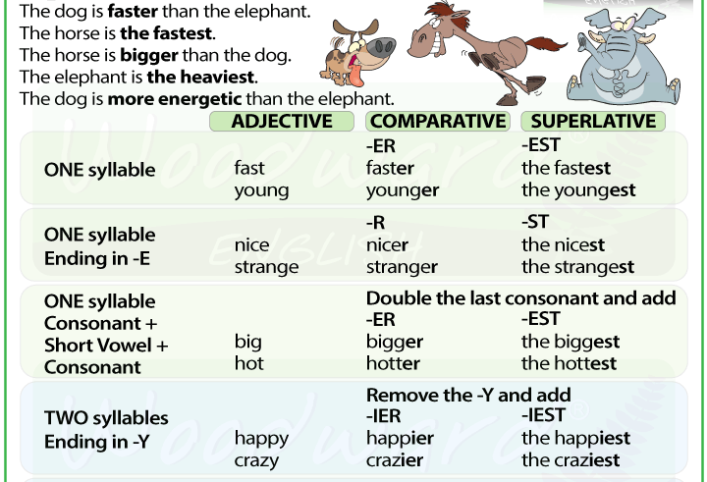

3rd step: Open your workbook, page 62 and do exercise 1, take a photo and send it to me.
(Odpri delovni zvezek na strani 62 in reši 1. nalogo, fotografiraj jo in mi pošlji rešitev na mail.)
4th step - weekly task: Do the missing exercises in your workbook up
to page 61.
- tedenska naloga (reši manjkajoče naloge v delovnem zvezku do strani 61)
STAY SAFE AND HEALTHY!

